Progress Report
Dong Wuzheng A0352274E
Yang Guanxi A0356000X
Gao Hongye A0351080R

1 Introduction
This project implements a distributed attention kernel for long sequences and measures its correctness and runtime on CPU and NVIDIA GPUs. Standard attention computes every query against every key, so for fixed feature dimensions, the arithmetic complexity of dense attention grows quadratically with sequence length $N$.. Ring Attention distributes query and key/value blocks across GPUs: each GPU keeps its query block, while key/value blocks circulate between ranks. This lets the GPUs share the attention work without gathering the complete key/value sequence on every device.

2 Methodology

2.1 Attention Formulation and Notation
For queries$Q$, keys$K$, values$V$, and key dimension$d_{k}$, the reference operation is:
$$\begin{aligned}S&=\frac{QK^{⊤}}{\sqrt{d_{k}}} \\ O&=\text{softmax}\left(S+M\right)V\end{aligned}$$
In the implementation and experiment tables, $d$ denotes the query and key dimension, corresponding to $d_{k}$ in the equation, and $d_{v}$ denotes the value dimension. Thus, $Q,K∈R^{N×d}$, $V∈R^{N×d_{v}}$, and $O∈R^{N×d_{v}}$.
Here M is zero for allowed positions and −∞ for masked positions. In causal attention, a query at position i cannot use a key at a later position j> i.

2.2 Ring Attention and Blocking
Ring Attention partitions the query rows across GPU ranks. Each rank keeps its assigned query block and processes key/value blocks that circulate between ranks. The query block is divided into tiles of $B_{q}$ rows, while the key and value blocks are divided into tiles of$B_{k}$ rows. For each query tile, a rank computes attention against the key/value tiles as they arrive around the ring.
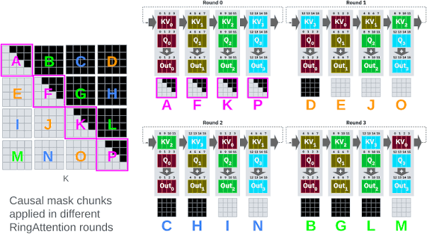
Figure 1. Each rank retains its query block and processes key/value tiles circulated around the GPU ring.
For each query row, the implementation maintains a running maximum $m$, a softmax denominator$l$, and a weighted value sum$u$. For a new score tile $s$, it updates these quantities as follows:
$$m'=\max\left(m,\max_{j}{s_{j}}\right), l'=e^{m-m'}l+\sum_{j}{e^{s_{j}-m'}}, \\ u'=e^{m-m'}u+\sum_{j}{e^{s_{j}-m'}}v_{j}.$$
After all key/value tiles have been processed, the output row is $u/l$. This online update avoids storing the full$N×N$ attention-score matrix; intermediate scores are processed tile by tile. With fixed feature dimensions, the attention computation still grows quadratically with $N$.

3 Experiment
We evaluated five execution configurations: serial CPU, OpenMP CPU, local single-GPU CUDA on an NVIDIA RTX 4090, single-GPU CUDA on a Vanda A40, and two-node MPI+CUDA on two Vanda A40 GPUs. Performance measurements used$d=d_{v}=64$ and five repetitions unless otherwise stated. Small correctness tests used $N=257$, $d=31$, and $d_{v}=19$.

3.1 Serial CPU (FP64)
The serial CPU implementation used FP64 arithmetic and served as the CPU reference. Performance was measured at sequence lengths$N=512$, 1024, 2048, and 4096. Table 1 reports the measured runtimes.
Table 1. Serial CPU FP64 runtimes with$d=d_{v}=64$.
Sequence length $N$ | Median runtime
512 | 17.515 ms
1024 | 70.418 ms
2048 | 263.479 ms
4096 | 913.966 ms

3.2 OpenMP CPU (FP64)
The OpenMP CPU implementation used FP64 arithmetic. At $N=4096$, with $d=d_{v}=64$, we measured runtimes using 1, 2, 4, and 8 threads. Table 2 reports the measured runtimes.
Table 2. OpenMP CPU runtimes at $N=4096$,$d=d_{v}=64$.
CPU threads | Median runtime
1 | 914.491 ms
2 | 450.942 ms
4 | 236.177 ms
8 | 142.854 ms

3.3 Loval single GPU CUDA (RTX4090)
The local CUDA implementation was run on a single NVIDIA GeForce RTX 4090. The tests covered full and causal attention at $N=257$, followed by full-attention runs at $N=1024$ and $N=4096$. All four tests were checked against the FP64 CPU reference and passed validation.
Table 3. Local RTX 4090 CUDA validation and runtime results.
Test | Runtime | Validation
$N=257$, full attention | 0.609 ms | PASS
$N=257$, causal attention | 0.589 ms | PASS
$N=1024$, full attention, 5 repetitions | 0.718 ms | PASS
$N=4096$, full attention, 5 repetitions | 8.044 ms | PASS
The terminal captures which show the local GPU and the recorded CUDA validation and benchmark outputs are attached in Appendix 1.

3.4 Vanda Single GPU CUDA (A40, FP32)
The single-GPU CUDA implementation was run on one Vanda A40 GPU using FP32 arithmetic. The Vanda environment used CUDA Toolkit 12.4. Performance was measured at $N=512$, 1024, 2048, and 4096, with $d=d_{v}=64$.
Table 4. Vanda single-GPU A40 FP32 runtimes with $d=d_{v}=64$.
Sequence length $N$ | Median runtime
512 | 0.248 ms
1024 | 0.648 ms
2048 | 2.345 ms
4096 | 8.845 ms

3.5 Vanda Two-Node MPI+CUDA (2 × A40, FP32)
The distributed CUDA implementation was run on two Vanda nodes, with one A40 GPU per node. It used FP32 arithmetic, CUDA Toolkit 12.4, Open MPI 4.1.8, and host-staged MPI communication.
The first two-node attempt, Job 1475534, received two A40 nodes but stopped before GPU computation because Open MPI placed both ranks on the first node. We changed the launch mapping to place one rank on each node. The subsequent smoke test and full benchmark confirmed distinct rank hosts and completed successfully.
The reported two-node MPI+CUDA runtime was 5.115 ms at $N=4096$ and 18.908 ms at $N=8192$. Full and causal correctness tests at $N=257$, $d=31$, and $d_{v}=19$ both passed.
Table 5. Two-node Vanda correctness results against the FP64 CPU reference.
Attention mode | Input | Maximum absolute error | Relative L2 error | Result
Full | $$N=257, d=31, d_{v}=19$$ | 2.5164e-08 | 1.2781e-07 | PASS
Causal | $$N=257, d=31, d_{v}=19$$ | 7.4686e-08 | 8.9793e-08 | PASS

4 Result

4.1 Performance Comparison
Table 6 compares the serial CPU FP64 and Vanda single-GPU FP32 runtimes across sequence lengths. The CPU and GPU implementations use different numerical precision, so these measurements provide project baselines rather than a controlled comparison at identical precision.
Table 6. Serial CPU and Vanda single-GPU performance with \(d=d_v=64\).
$$N$$ | Serial CPU FP64 | Vanda A40, one-GPU FP32
512 | 17.515 ms | 0.248 ms
1024 | 70.418 ms | 0.648 ms
2048 | 263.479 ms | 2.345 ms
4096 | 913.966 ms | 8.845 ms
At$N=4096$, the serial CPU took 913.966 ms, the eight-thread OpenMP implementation took 142.854 ms, the single Vanda A40 took 8.845 ms, and the two-node MPI+CUDA run took 5.115 ms. Figure 6 compares these recorded runtimes.
Figure 6. Runtime comparison at $N=4096$, $d=d_{v}=64$. Runtime is shown on a logarithmic horizontal axis.
The local RTX 4090 also passed the reported validation tests. At \(N=257\), \(d=31\), and $d_{v}=19$, its full-attention output had a maximum absolute error of 3.5195e-08 and a relative L2 error of 1.6572e-07 against the FP64 reference.

4.2 Scaling and Tile-Size Analysis

5 Conclusion

4 Result
4.1 Performance Comparison
4.2 Scaling and Tile-Size Analysis
For fixed feature dimensions, dense attention requires approximately quadratic arithmetic work as \(N\) increases. Table 7 reports the runtime ratio for each doubling of sequence length.
Table 7. Runtime growth when sequence length doubles, with \(d=d_v=64\).
\(N\) | Serial CPU FP64 | Vanda A40, one-GPU FP32 | Runtime ratio vs previous row, CPU / GPU
512 | 17.515 ms | 0.248 ms | —
1024 | 70.418 ms | 0.648 ms | 4.02× / 2.61×
2048 | 263.479 ms | 2.345 ms | 3.74× / 3.62×
4096 | 913.966 ms | 8.845 ms | 3.47× / 3.77×
The measurements broadly follow the expected quadratic trend. Doubling \(N\) increased the CPU runtime by 3.47–4.02× and the single-GPU runtime by 2.61–3.77×.
For OpenMP, increasing the thread count from one to eight reduced runtime from 914.491 ms to 142.854 ms at \(N=4096\). The measured reduction demonstrates that the CPU implementation benefits from parallel execution within the tested thread range.
The two-node experiment also tested different query and key/value tile sizes. Table 8 reports the measured runtimes.
Table 8. Two-node MPI+CUDA runtimes for different tile sizes.
\(N\) | Query tile size \(b_q\) | Key/value tile size \(b_k\) | Median runtime
2048 | 64 | 128 | 4.011 ms
2048 | 64 | 256 | 2.493 ms
2048 | 128 | 128 | 2.288 ms
2048 | 128 | 256 | 1.469 ms
4096 | 64 | 128 | 15.308 ms
4096 | 64 | 256 | 9.361 ms
4096 | 128 | 128 | 8.169 ms
4096 | 128 | 256 | 5.124 ms
Among the tested configurations, \(b_q=128\) and \(b_k=256\) produced the lowest runtime at both sequence lengths. Larger tiles can reduce the number of tile iterations and allow more work to be performed on each loaded block. The measurements establish the observed improvement; they do not independently identify the contribution of each hardware or communication effect.
In the separate full-versus-causal measurements at \(b_q=128\), \(b_k=256\), the full and causal medians were 5.226 ms and 5.687 ms at \(N=4096\), and 18.881 ms and 18.670 ms at \(N=8192\).
Table 9 reports the weak-scaling pairs. Increasing \(N\) by approximately \(\sqrt{2}\) when moving from one GPU to two GPUs is intended to keep the arithmetic work per GPU approximately constant.
Table 9. Recorded one-GPU and two-node weak-scaling results.
One-GPU \(N\) | One-GPU runtime | Two-node \(N\) | Two-node runtime
512 | 0.248 ms | 724 | 0.708 ms
1024 | 0.648 ms | 1448 | 1.263 ms
2048 | 2.345 ms | 2896 | 3.181 ms
4096 | 8.845 ms | 5793 | 11.225 ms
The two-node runtime was higher in every recorded pair, although the relative difference decreased for larger workloads. Approximately constant arithmetic work per GPU therefore did not produce constant runtime. The available aggregate timings do not separate GPU computation, host-staged transfers, MPI communication, and synchronization, so the runtime increase cannot be attributed solely to communication.

Step 1 Preparation and Execution
We recorded a double-precision serial CPU reference and an OpenMP CPU baseline. We then compiled and ran the CUDA kernel on the local RTX 4090 and on Vanda A40 GPUs. Vanda used CUDA Toolkit 12.4, Open MPI 4.1.8, and host-staged MPI communication.
The first two-node attempt (1475534) received two A40 nodes but stopped before GPU computation: Open MPI placed both ranks on the first node. We changed the launch mapping to one rank per node. The subsequent smoke test and full benchmark both confirmed distinct rank hosts and completed successfully.
For each query row, the kernel maintains the running maximum m, the softmax denominator ℓ, and the weighted value sum u. For a new score tile sⱼ and corresponding values vⱼ, it updates:
$$\begin{aligned}m^{'}&=\max\left(m,\max_{j}{s_{j}}\right) \\ α&=\exp\left(m-m^{'}\right), p_{j}=\exp\left(s_{j}-m^{'}\right) \\ l^{'}&=αl+\sum_{j}{p_{j}} \\ u^{'}&=αu+\sum_{j}{p_{j}}v_{j} \\ o&=\frac{u^{'}}{l^{'}}\end{aligned}$$This online update avoids storing the full N × N score matrix. The total attention arithmetic remains quadratic in N; distribution reduces the per-GPU share and the streaming update bounds intermediate score storage to a tile.

Step 2 Results

CPU and GPU performance
CPU serial and OpenMP runs use FP64; the CUDA and MPI+CUDA runs use FP32. Each timing below is a median of five repetitions unless noted. Cross-device timings are useful project baselines, not a controlled comparison of identical host hardware.
N (d=dv=64) |  | Serial CPU FP64 | Vanda A40, one-GPU FP32
512 |  | 17.515 ms | 0.248 ms
1024 |  | 70.418 ms | 0.648 ms
2048 |  | 263.479 ms | 2.345 ms
4096 |  | 913.966 ms | 8.845 ms
N | Serial CPU FP64 | Vanda A40, one-GPU FP32 | Runtime ratio vs previous row (CPU / GPU)
512 | 17.515 ms | 0.248 ms | —
1024 | 70.418 ms | 0.648 ms | 4.02× / 2.61×
2048 | 263.479 ms | 2.345 ms | 3.74× / 3.62×
4096 | 913.966 ms | 8.845 ms | 3.47× / 3.77×
For fixed$d=d_{v}=64$, dense attention has $O\left(N^{2}d\right)$ arithmetic complexity, so its runtime is expected to grow approximately quadratically as $N$ increases. In the table, doubling $N$increases the CPU runtime by 3.47–4.02× and the one-GPU runtime by 2.61–3.77×. These measurements broadly follow the expected quadratic trend; deviations from exactly 4× can arise from fixed overheads and hardware effects.
At N=4096, OpenMP FP64 with 8 threads took 142.854 ms. The two-node MPI+CUDA result took 5.115 ms at N=4096 and 18.908 ms at N=8192. The separate local RTX 4090 check (N=257, d=31, dv=19) took 0.574 ms.
OpenMP scaling at N=4096, d=dv=64:
CPU threads | Median time
1 | 914.491 ms
2 | 450.942 ms
4 | 236.177 ms
8 | 142.854 ms

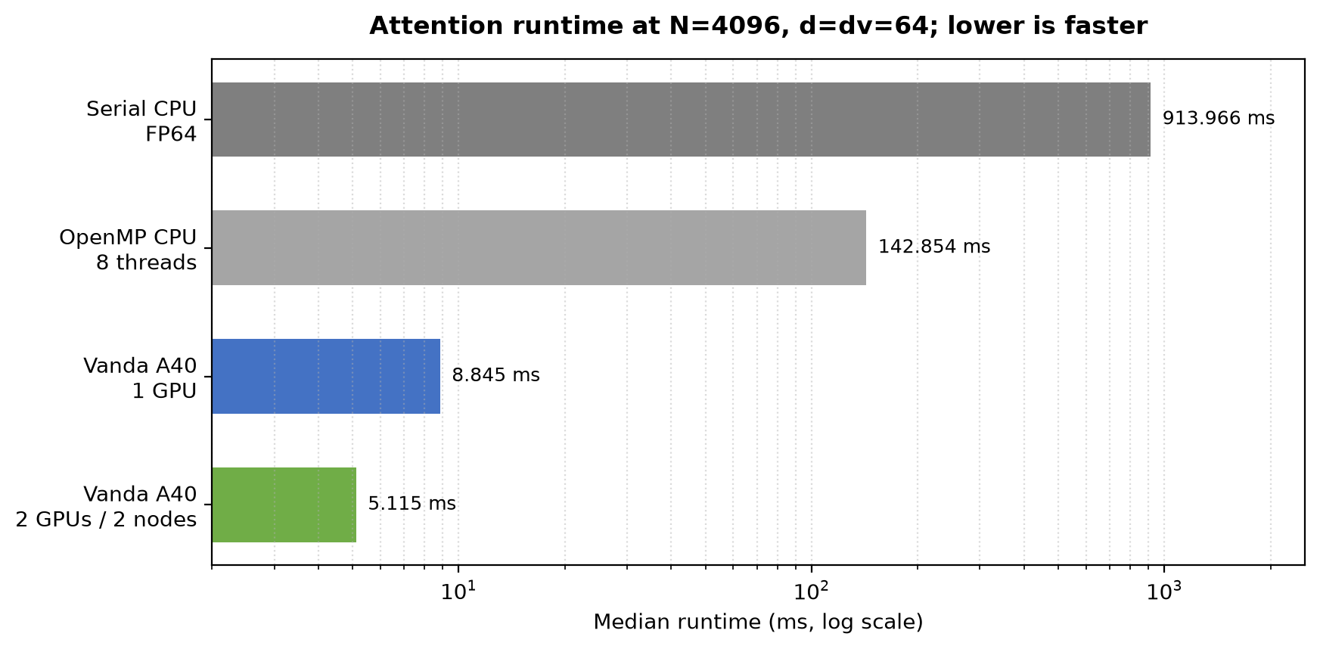
Figure 2. Runtime comparison at the same 4096-token workload
The two-node full experiment also covered tile sizes and causal masking:
N | bq | bk | Median time (ms)
2048 | 64 | 128 | 4.011
2048 | 64 | 256 | 2.493
2048 | 128 | 128 | 2.288
2048 | 128 | 256 | 1.469
4096 | 64 | 128 | 15.308
4096 | 64 | 256 | 9.361
4096 | 128 | 128 | 8.169
4096 | 128 | 256 | 5.124

At bq=128, bk=256, the full and causal medians were 5.226 ms and 5.687 ms for N=4096, and 18.881 ms and 18.670 ms for N=8192.

Correctness and weak scaling
Run | Input | Maximum absolute error | Relative L2 error | Result
Local RTX 4090 | N=257, d=31, dv=19, full | 3.5195e-08 | 1.6572e-07 | PASS
Vanda, two nodes | N=257, d=31, dv=19, full | 2.5164e-08 | 1.2781e-07 | PASS
Vanda, two nodes | N=257, d=31, dv=19,causal | 7.4686e-08 | 8.9793e-08 | PASS

Ring Attention CUDA Kernel Validation on a Single RTX 4090
To verify the local CUDA implementation independently of the distributed Vanda runs, we reran the attention kernel on a single NVIDIA GeForce RTX 4090. The tests covered full attention and causal attention at$N=257$, followed by full-attention benchmarks at $N=1024$ and $N=4096$. All four tests were checked against the FP64 reference; each passed validation.
Test | duration | Verification
N=257，full | 0.609 ms | PASS
N=257，causal | 0.589 ms | PASS
N=1024，full，5 times | 0.718 ms | PASS
N=4096，full，5times | 8.044 ms | PASS
Table 6 Local RTX 4090 CUDA validation and runtime results.
The RTX 4090 runs confirm that both full and causal attention produce outputs within a small numerical error of the FP64 reference. Runtime increased from 0.718 ms at $N=1024$to 8.044 ms at $N=4096$
The source code for the RTX 4090 runs is provided in Appendix Code Zip, and the corresponding terminal screenshots are provided in Appendix 3.

One-GPU N / time (ms) | Two-node N / time (ms) | Interpretation
512 / 0.248 | 724 / 0.708 | Approx. constant work per GPU
1024 / 0.648 | 1448 / 1.263 | Approx. constant work per GPU
2048 / 2.345 | 2896 / 3.181 | Approx. constant work per GPU
4096 / 8.845 | 5793 / 11.225 | Approx. constant work per GPU

Conclusion
This project successfully validates both the single-GPU CUDA attention kernel and the cross-node two-node MPI ring pipeline on local RTX 4090 and cluster Vanda A40 GPUs.
Distributed Communication & Deployment: We identified and resolved the initial multi-node launch failure (Job 1475534), where Open MPI incorrectly co-located both ranks on a single node. Adopting explicit --map-by ppr:1:node mapping ensured true multi-node distribution.
Correctness & Precision: Under $N=257,d=31,dv=19$ validation configurations against an FP64 CPU reference, both full and causal Ring Attention kernels achieved maximum absolute errors on the order of ${10}^{-8}$ and relative $L_{2}$ errors on the order of ${10}^{-7}$, successfully passing all verification checks.
Performance Scaling: For $N=4096,d=dv=64$, OpenMP CPU scaling reduced runtime from 913.97 ms (serial) to 142.85 ms (8 threads). Transitioning to a single Vanda A40 GPU achieved 8.85 ms (~103× speedup over serial CPU), and two-node MPI+CUDA Ring Attention further reduced runtime to 5.12 ms (a 1.73× speedup over single-GPU).
Tile Sizing & Causal Masking: Increasing tile dimensions (e.g., $bq=128,bk=256$) significantly boosted compute throughput, lowering two-node runtime at $N=4096$ from 15.31 ms to 5.12 ms. Under identical tile settings, causal and full attention execution times remained close (5.69 ms vs. 5.23 ms at $N=4096$).
Weak Scaling Behavior: Scaling sequence length $N$ by $\sqrt{2}$ alongside GPU rank count maintains approximate constant workload per device, exhibiting favorable weak scaling (e.g., 8.85 ms for $N=4096$ on 1 GPU vs. 11.23 ms for $N=5793$ on 2 nodes). This confirms that online softmax streaming and ring communication effectively reduce memory overhead while maintaining computational efficiency for scaled sequence lengths.

APPENDIX

Appendix 1: Ring Attention CUDA Kernel Validation on RTX 4090
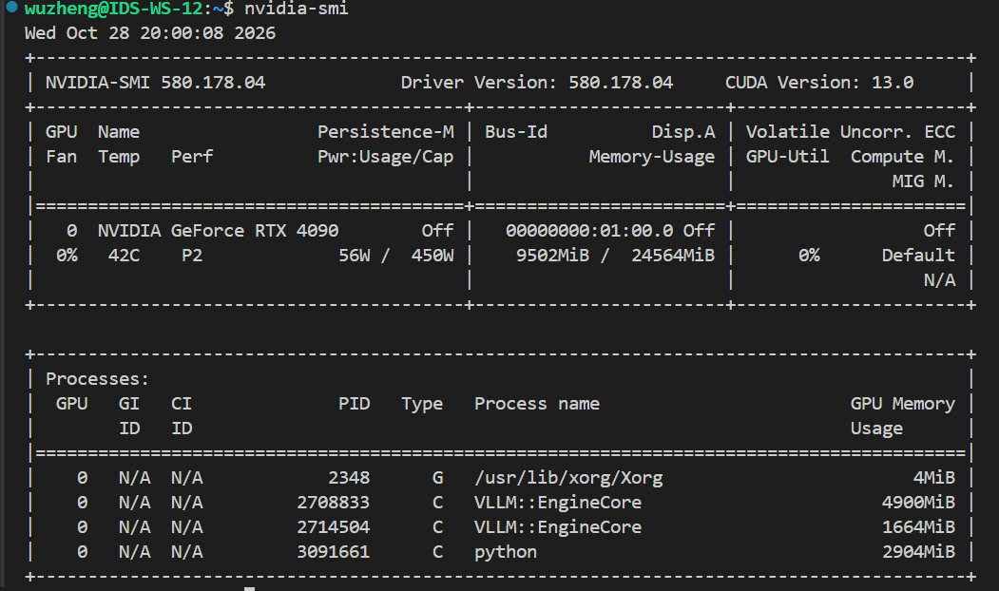
Figure 1. Local NVIDIA GeForce RTX 4090 GPU identification.
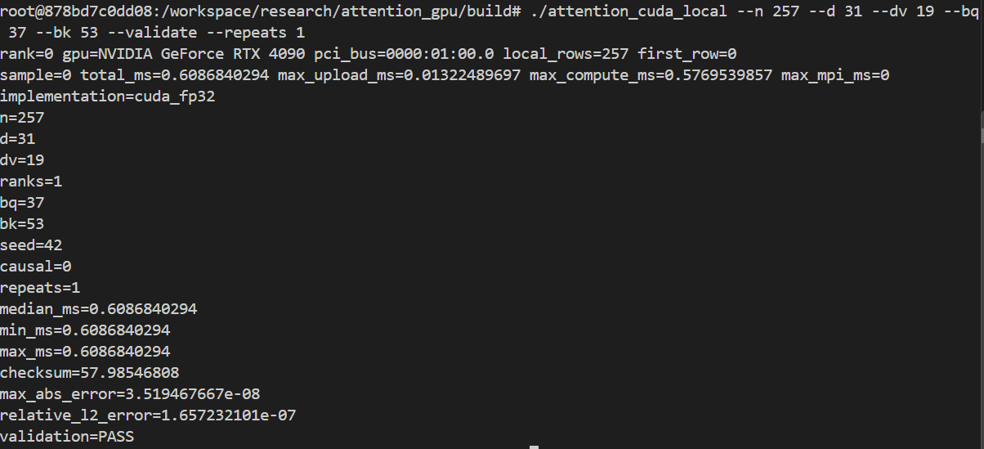
Figure 2. Local RTX 4090 full-attention validation at$N=257$.
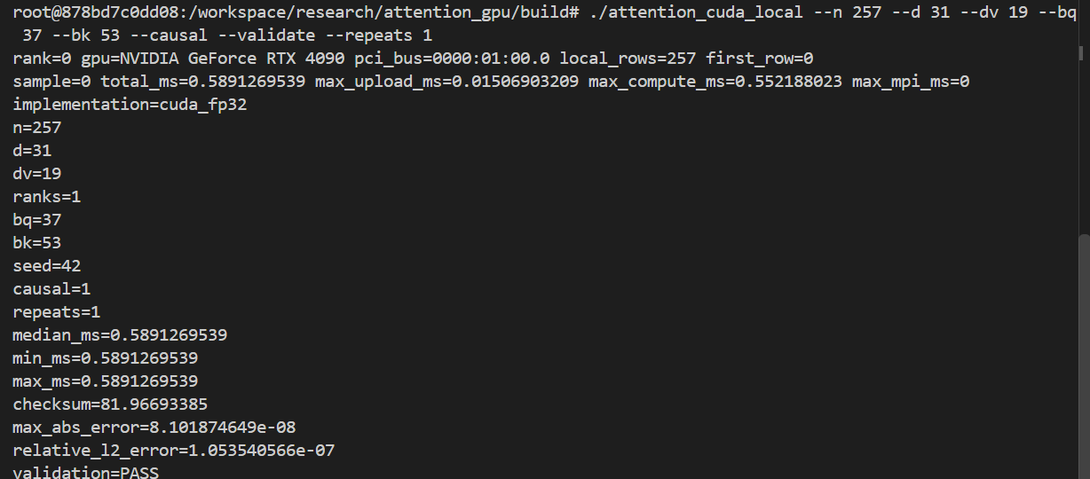
Figure 3. Local RTX 4090 causal-attention validation at $N=257$.
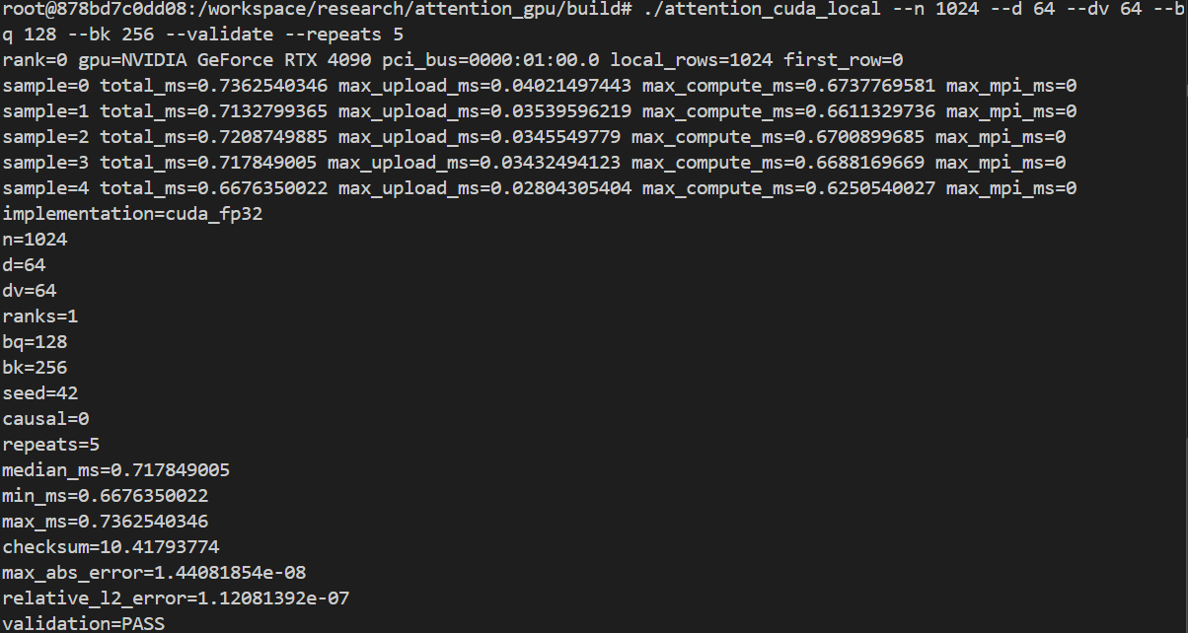
Figure 4. Local RTX 4090 full-attention benchmark at $N=1024$.
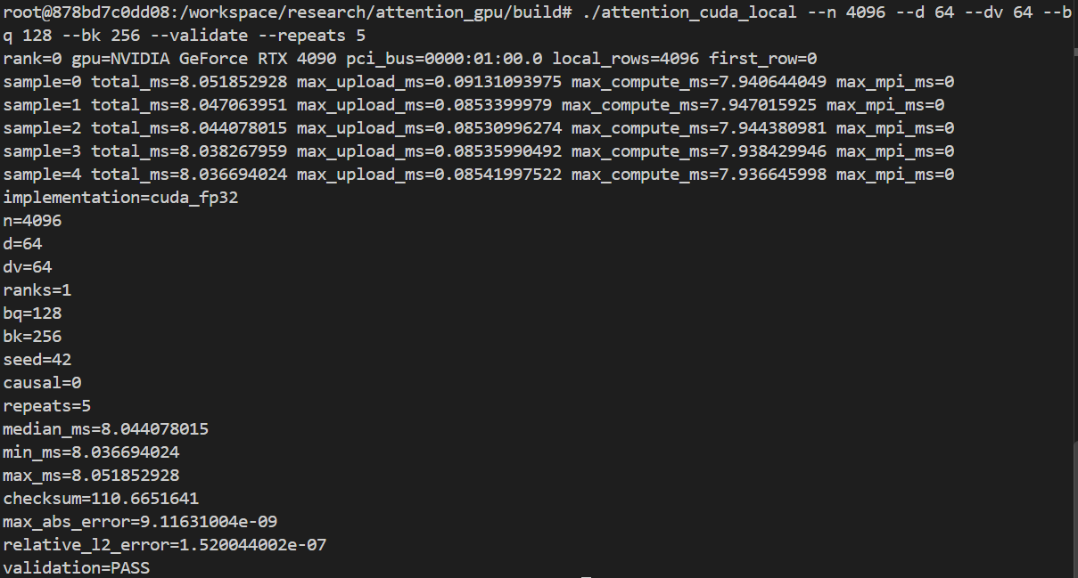
Figure 5. Local RTX 4090 full-attention benchmark at $N=4096$.

Appendix Code
1. # JOB 1470561 | scripts/vanda_serial_free.pbs
2. #!/bin/bash
3. #PBS -q auto_free
4. #PBS -N attention_serial_cpu
5. #PBS -j oe
6. #PBS -l select=1:ncpus=1:mpiprocs=1:mem=4gb
7. #PBS -l walltime=00:30:00
8. set -euo pipefail
9. cd "$PBS_O_WORKDIR"
10. mkdir -p bin results
11. module load gcc/13.1.0
12. g++ -O3 -std=c++11 src/attention_serial.cpp -o bin/attention_serial
13. bin/attention_serial --n 257 --d 31 --dv 19 --repeats 5 --check > results/serial_cpu_257.txt
14. for n in 512 1024 2048 4096; do
15. bin/attention_serial --n "$n" --d 64 --dv 64 --repeats 5 > "results/serial_cpu_${n}.txt"
16. done
17. bin/attention_serial --n 2048 --d 64 --dv 64 --causal --repeats 5 > results/serial_cpu_2048_causal.txt
18. echo "serial_cpu_benchmarks=PASS"
19. # JOB 1470659 | scripts/vanda_openmp_free.pbs
20. #!/bin/bash
21. #PBS -q auto_free
22. #PBS -N attention_openmp_opt
23. #PBS -j oe
24. #PBS -l select=1:ncpus=8:mpiprocs=1:ompthreads=8:mem=16gb
25. #PBS -l walltime=00:30:00
26. set -euo pipefail
27. cd "$PBS_O_WORKDIR"
28. mkdir -p bin results/openmp_opt
29. module load gcc/13.1.0
30. g++ -O3 -std=c++17 -fopenmp src/attention_openmp.cpp -o bin/attention_openmp_opt
31. OMP_PLACES=cores OMP_PROC_BIND=close bin/attention_openmp_opt --n 257 --d 31 --dv 19 --threads 8 --repeats 3 --check > results/openmp_opt/openmp_257_t8.txt
32. for n in 1024 2048 4096 8192; do
33. for t in 1 2 4 8; do
34. OMP_PLACES=cores OMP_PROC_BIND=close bin/attention_openmp_opt --n "$n" --d 64 --dv 64 --threads "$t" --repeats 5 > "results/openmp_opt/openmp_${n}_t${t}.txt"
35. done
36. done
37. echo "openmp_cpu_benchmarks=PASS"
38. # LOCAL NVIDIA RTX 4090 | one-GPU CUDA validation
39. /tmp/attention_cuda_env/bin/nvcc -O2 -std=c++17 -arch=sm_89 \
40. -I/tmp/attention_cuda_env/include \
41. -I/opt/conda/lib/python3.11/site-packages/nvidia/cublas/include \
42. /tmp/attention_local/src/attention_cuda.cu \
43. -L/tmp/attention_cuda_env/lib -lcublas \
44. -o /tmp/attention_local/bin/attention_cuda
45. LD_LIBRARY_PATH=/tmp/attention_cuda_env/lib:/opt/conda/lib/python3.11/site-packages/nvidia/cublas/lib:/opt/conda/lib/python3.11/site-packages/nvidia/cuda_runtime/lib:${LD_LIBRARY_PATH:-} \
46. /tmp/attention_local/bin/attention_cuda \
47. --n 257 --d 31 --dv 19 --bq 37 --bk 53 --validate --repeats 1
48. # JOB 1475534 | initial placement check | no attention kernel was launched
49. MPI=(mpirun --prefix "$MPI_HOME" --hostfile "$HOSTFILE" -x PATH -x LD_LIBRARY_PATH -np 2)
50. HOST_OUTPUT="$("${MPI[@]}" hostname)"
51. mapfile -t LAUNCHED_HOSTS < <(printf '%s\n' "$HOST_OUTPUT" | sort -u)
52. printf 'MPI rank hosts: %s\n' "${LAUNCHED_HOSTS[*]}"
53. if [[ "${#LAUNCHED_HOSTS[@]}" -ne 2 ]]; then
54. echo "ERROR: expected two MPI ranks on two distinct nodes"
55. exit 22
56. fi

57. # JOB 1476015 | scripts/vanda_attention_multinode_smoke_free.pbs
58. #!/bin/bash
59. #PBS -q auto_free
60. #PBS -N attention_2node_smoke
61. #PBS -j oe
62. #PBS -l select=2:ncpus=4:mpiprocs=1:ngpus=1:node_pool=gpu_free:mem=16GB
63. #PBS -l place=scatter
64. #PBS -l walltime=00:10:00
65. set -euo pipefail
66. cd "$PBS_O_WORKDIR"
67. module load gcc/13.1.0
68. module load cuda12.4/toolkit/12.4.1
69. module load openmpi/gcc/64/4.1.8
70. MPI_BIN="$(readlink -f "$(command -v mpirun)")"
71. MPI_HOME="${MPI_HOME:-$(dirname "$(dirname "$MPI_BIN")")}"
72. export MPI_HOME PATH="$MPI_HOME/bin:$PATH"
73. export LD_LIBRARY_PATH="$MPI_HOME/lib:$MPI_HOME/lib64:${LD_LIBRARY_PATH:-}"
74. export OMPI_MCA_plm_rsh_agent=ssh
75. OUT=results/multinode_smoke_free
76. mkdir -p "$OUT" bin
77. HOSTFILE="$OUT/mpi_hosts"
78. sort -u "$PBS_NODEFILE" > "$HOSTFILE"
79. [[ "$(wc -l < "$HOSTFILE")" -eq 2 ]]
80. nvcc -O3 -std=c++17 -arch=sm_86 -ccbin mpicxx -DATTENTION_MPI=1 -DOMPI_SKIP_MPICXX=1 src/attention_cuda.cu -lcublas -o bin/attention_mpi_cuda
81. MPI=(mpirun --prefix "$MPI_HOME" --hostfile "$HOSTFILE" --map-by ppr:1:node --rank-by node -x PATH -x LD_LIBRARY_PATH -np 2)
82. HOST_OUTPUT="$("${MPI[@]}" hostname)"
83. mapfile -t RANK_HOSTS < <(printf '%s\n' "$HOST_OUTPUT" | sort -u)
84. [[ "${#RANK_HOSTS[@]}" -eq 2 ]]
85. "${MPI[@]}" bin/attention_mpi_cuda --n 257 --d 31 --dv 19 --bq 37 --bk 53 --validate --repeats 1
86. echo "MULTINODE_SMOKE=PASS"
87. # JOB 1476284 | scripts/vanda_attention_multinode_all_free.pbs
88. #!/bin/bash
89. #PBS -q auto_free
90. #PBS -N attention_2node_all
91. #PBS -j oe
92. #PBS -l select=2:ncpus=4:mpiprocs=1:ngpus=1:node_pool=gpu_free:mem=16GB
93. #PBS -l place=scatter
94. #PBS -l walltime=01:00:00
95. set -euo pipefail
96. cd "$PBS_O_WORKDIR"
97. mkdir -p bin results/multinode_all
98. module load gcc/13.1.0
99. module load cuda12.4/toolkit/12.4.1
100. module load openmpi/gcc/64/4.1.8
101. MPI_BIN="$(readlink -f "$(command -v mpirun)")"
102. MPI_HOME="${MPI_HOME:-$(dirname "$(dirname "$MPI_BIN")")}"
103. export MPI_HOME PATH="$MPI_HOME/bin:$PATH"
104. export LD_LIBRARY_PATH="$MPI_HOME/lib:$MPI_HOME/lib64:${LD_LIBRARY_PATH:-}"
105. export OMPI_MCA_plm_rsh_agent=ssh
106. OUT=results/multinode_all
107. HOSTFILE="$OUT/mpi_hosts"
108. sort -u "$PBS_NODEFILE" > "$HOSTFILE"
109. [[ "$(wc -l < "$HOSTFILE")" -eq 2 ]]
110. g++ -O3 -std=c++11 src/attention_serial.cpp -o bin/attention_serial
111. nvcc -O3 -std=c++17 -arch=sm_86 src/attention_cuda.cu -lcublas -o bin/attention_cuda
112. nvcc -O3 -std=c++17 -arch=sm_86 -ccbin mpicxx -DATTENTION_MPI=1 -DOMPI_SKIP_MPICXX=1 src/attention_cuda.cu -lcublas -o bin/attention_mpi_cuda
113. MPI=(mpirun --prefix "$MPI_HOME" --hostfile "$HOSTFILE" --map-by ppr:1:node --rank-by node -x PATH -x LD_LIBRARY_PATH -np 2)
114. HOST_OUTPUT="$("${MPI[@]}" hostname)"
115. mapfile -t LAUNCHED_HOSTS < <(printf '%s\n' "$HOST_OUTPUT" | sort -u)
116. [[ "${#LAUNCHED_HOSTS[@]}" -eq 2 ]]
117. "${MPI[@]}" bin/attention_mpi_cuda --n 257 --d 31 --dv 19 --bq 37 --bk 53 --validate --repeats 3 --output "$OUT/ring_257.csv"
118. "${MPI[@]}" bin/attention_mpi_cuda --n 257 --d 31 --dv 19 --bq 37 --bk 53 --causal --validate --repeats 3 --output "$OUT/ring_causal_257.csv"
119. for n in 1024 2048 4096 8192; do
120. "${MPI[@]}" bin/attention_mpi_cuda --n "$n" --d 64 --dv 64 --bq 128 --bk 256 --repeats 5
121. done
122. for n in 2048 4096; do
123. for bq_bk in "64 128" "64 256" "128 128" "128 256"; do
124. read -r bq bk <<< "$bq_bk"
125. "${MPI[@]}" bin/attention_mpi_cuda --n "$n" --d 64 --dv 64 --bq "$bq" --bk "$bk" --repeats 3
126. done
127. done
128. for n in 4096 8192; do
129. for mask in full causal; do
130. args=()
131. if [[ "$mask" == causal ]]; then args+=(--causal); fi
132. "${MPI[@]}" bin/attention_mpi_cuda --n "$n" --d 64 --dv 64 --bq 128 --bk 256 --repeats 5 "${args[@]}"
133. done
134. done
135. for pair in "512 724" "1024 1448" "2048 2896" "4096 5793"; do
136. read -r n1 n2 <<< "$pair"
137. bin/attention_cuda --n "$n1" --d 64 --dv 64 --bq 128 --bk 256 --repeats 5
138. "${MPI[@]}" bin/attention_mpi_cuda --n "$n2" --d 64 --dv 64 --bq 128 --bk 256 --repeats 5
139. done
140. echo "MULTINODE_FULL_EXPERIMENTS=PASS"

141. # JOB 1476448 | scripts/vanda_attention_multinode_all_batch.pbs
142. #!/bin/bash
143. #PBS -P personal-dongwuzheng
144. #PBS -q auto
145. #PBS -N attention_2node_batch
146. #PBS -j oe
147. #PBS -l select=2:ncpus=4:mpiprocs=1:ngpus=1:mem=16GB
148. #PBS -l place=scatter
149. #PBS -l walltime=01:00:00
150. set -euo pipefail
151. cd "$PBS_O_WORKDIR"
152. mkdir -p bin results/multinode_all
153. module load gcc/13.1.0
154. module load cuda12.4/toolkit/12.4.1
155. module load openmpi/gcc/64/4.1.8
156. MPI_BIN="$(readlink -f "$(command -v mpirun)")"
157. MPI_HOME="${MPI_HOME:-$(dirname "$(dirname "$MPI_BIN")")}"
158. export MPI_HOME PATH="$MPI_HOME/bin:$PATH"
159. export LD_LIBRARY_PATH="$MPI_HOME/lib:$MPI_HOME/lib64:${LD_LIBRARY_PATH:-}"
160. export OMPI_MCA_plm_rsh_agent=ssh
161. OUT=results/multinode_all
162. HOSTFILE="$OUT/mpi_hosts"
163. sort -u "$PBS_NODEFILE" > "$HOSTFILE"
164. [[ "$(wc -l < "$HOSTFILE")" -eq 2 ]]
165. g++ -O3 -std=c++11 src/attention_serial.cpp -o bin/attention_serial
166. nvcc -O3 -std=c++17 -arch=sm_86 src/attention_cuda.cu -lcublas -o bin/attention_cuda
167. nvcc -O3 -std=c++17 -arch=sm_86 -ccbin mpicxx -DATTENTION_MPI=1 -DOMPI_SKIP_MPICXX=1 src/attention_cuda.cu -lcublas -o bin/attention_mpi_cuda
168. MPI=(mpirun --prefix "$MPI_HOME" --hostfile "$HOSTFILE" --map-by ppr:1:node --rank-by node -x PATH -x LD_LIBRARY_PATH -np 2)
169. HOST_OUTPUT="$("${MPI[@]}" hostname)"
170. mapfile -t LAUNCHED_HOSTS < <(printf '%s\n' "$HOST_OUTPUT" | sort -u)
171. [[ "${#LAUNCHED_HOSTS[@]}" -eq 2 ]]
172. "${MPI[@]}" bin/attention_mpi_cuda --n 257 --d 31 --dv 19 --bq 37 --bk 53 --validate --repeats 3 --output "$OUT/ring_257.csv"
173. "${MPI[@]}" bin/attention_mpi_cuda --n 257 --d 31 --dv 19 --bq 37 --bk 53 --causal --validate --repeats 3 --output "$OUT/ring_causal_257.csv"
174. for n in 1024 2048 4096 8192; do
175. "${MPI[@]}" bin/attention_mpi_cuda --n "$n" --d 64 --dv 64 --bq 128 --bk 256 --repeats 5
176. done
177. for n in 2048 4096; do
178. for bq_bk in "64 128" "64 256" "128 128" "128 256"; do
179. read -r bq bk <<< "$bq_bk"
180. "${MPI[@]}" bin/attention_mpi_cuda --n "$n" --d 64 --dv 64 --bq "$bq" --bk "$bk" --repeats 3
181. done
182. done
183. for n in 4096 8192; do
184. for mask in full causal; do
185. args=()
186. if [[ "$mask" == causal ]]; then args+=(--causal); fi
187. "${MPI[@]}" bin/attention_mpi_cuda --n "$n" --d 64 --dv 64 --bq 128 --bk 256 --repeats 5 "${args[@]}"
188. done
189. done
190. for pair in "512 724" "1024 1448" "2048 2896" "4096 5793"; do
191. read -r n1 n2 <<< "$pair"
192. bin/attention_cuda --n "$n1" --d 64 --dv 64 --bq 128 --bk 256 --repeats 5
193. "${MPI[@]}" bin/attention_mpi_cuda --n "$n2" --d 64 --dv 64 --bq 128 --bk 256 --repeats 5
194. done
195. echo "MULTINODE_FULL_EXPERIMENTS=PASS"
196. # JOB 1475539 | scripts/vanda_attention_single_node_check_free.pbs
197. #!/bin/bash
198. #PBS -q auto_free
199. #PBS -N attention_1node_check
200. #PBS -j oe
201. #PBS -l select=1:ncpus=8:mpiprocs=2:ngpus=2:mem=16GB:node_pool=gpu_free
202. #PBS -l place=pack
203. #PBS -l walltime=00:10:00
204. set -euo pipefail
205. cd "$PBS_O_WORKDIR"
206. mkdir -p bin results/multinode_all
207. module load gcc/13.1.0
208. module load cuda12.4/toolkit/12.4.1
209. module load openmpi/gcc/64/4.1.8
210. MPI_BIN="$(readlink -f "$(command -v mpirun)")"
211. MPI_HOME="$(dirname "$(dirname "$MPI_BIN")")"
212. export PATH="$MPI_HOME/bin:$PATH"
213. export LD_LIBRARY_PATH="$MPI_HOME/lib:$MPI_HOME/lib64:${LD_LIBRARY_PATH:-}"
214. nvcc -O2 -std=c++17 -arch=sm_86 -ccbin mpicxx -DATTENTION_MPI=1 -DOMPI_SKIP_MPICXX=1 src/attention_cuda.cu -lcublas -o bin/attention_mpi_cuda_single_node_check
215. mpirun --prefix "$MPI_HOME" -np 2 --map-by ppr:2:node -x PATH -x LD_LIBRARY_PATH bin/attention_mpi_cuda_single_node_check --n 257 --d 31 --dv 19 --bq 37 --bk 53 --validate --repeats 1 --output "results/multinode_all/single_node_check_${PBS_JOBID}.csv"
216.

